Installation Guidline For SugarCRM:

Purpose:

This Module Import SugarCRM "Users", "Accounts", "Contacts", "Employees",
“Leads”,”Opportunities”,”'Meetings”, “calls”, “Cases”, “Emails and History”, “Project”,
Project Tasks, “Bugs”, “Document” into OpenERP Module.

pre-requirenments :
OpenERP-Requirenmants :
1.python2.4, and pythob2.4-dev
2.postgres-7.4 or postgres-8.1
3.SOAP for python – ZSI-2.0-rc3.tar.gz

Sugar-Requirenmants :
1.web-server
2.php5,
3.xml-rpc for php

Installation Of SugarCRM:

1.Install The MySQL Database Server using: sudo apt-get install mysql-server mysql-client
2.Install The Apache Webserver And PHP,xml-rpc for php:
sudo apt-get install apache2 apache2-doc apache2-mpm-prefork apache2-utils libexpat1 libapache2-mod-php5 php5-common php5-gd php5-idn php-pear php5-imap php5-mcrypt php5-mhash php5-mysql php5-sqlite php5-xmlrpc php5-xsl php5-curl
3.Now You can download SugarCRM Community Edition: http://www.sugarcrm.com/crm/download/sugar-suite.html
-We will Install SugarCRM in Apache's default vhost (document root /var/www) in
the directory /var/www/sugarcrm.
-So Unzip that and Move it using mv * /var/www/sugarcrm/
-Give permission using: chown -R www-data:www-data /var/www/sugarcrm
Now Use the Sugar Setup Wizard after copying the Sugar files into your web root. The Sugar Setup Wizard islocated at http://<yourServer>/<yourSugarDirectory>/install.php.
For example: http://localhost/Sugar-Full_6.2.0/install.php and follow sugarcrm configuaration wizard steps. Which is given in this Guidline link: http://www.sugarcrm.com/crm/support/documentation/SugarCommunityEdition/6.2/-docs-Application_Guides-Sugar_Community_Edition_Application_Guide_6.2.0GA-Sugar_Install_Upgrade.html#1182572

Enter the necessary information and click Send Registration to register your Sugar instance with SugarCRM; or click No Thanks to skip registration.

The Sugar login page displays on the screen. You can now log into Sugar with the Sugar admin name and password that you specified during installation. Here is Image:
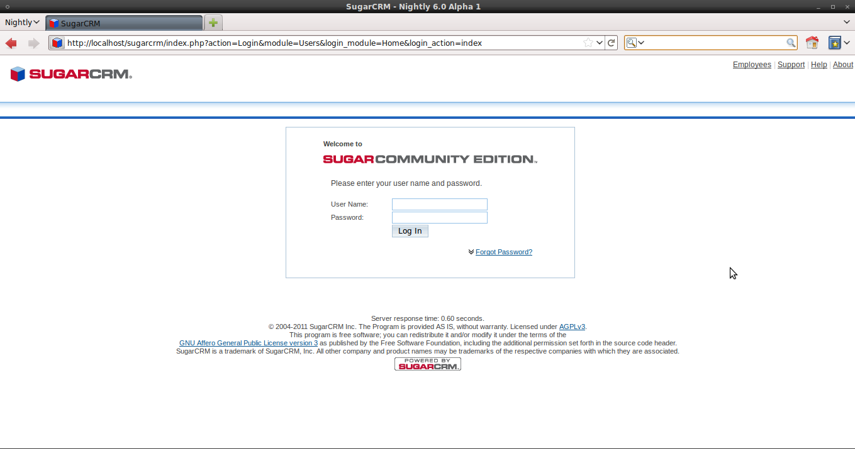
Install the SOAP framwwork for Python :
1. download the soap framework from http://pypi.python.org/pypi/ZSI/
extract the file “ZSI-2.0-rc3.tar.gz” and run following 2 commands
./setup.py build
./setup.py install
this will install soap framework for python.

Soap Api:
1.To integrate SugarCRM with third party applications .Uses the SugarCRM SOAP API.
2.SugarCRM SOAP API for authenticating a user by connecting to SugarCRM SOAP service.
3.You can connect to sugar soap using http. you need to configure your webserver to accept
http request. So your URL would be your own sugar installation and append
/soap.php to the URL,you will see Information For various method to get SugarCRM Module data plus a link to the WSDL.
Example of Soap Api: https://<yourinstance-name>/sugarcrm/soap.php

How to Use Module:
    - Install Module “import_sugarcrm”.
    - Now Run wizard From “Sales=>Import=>Import SugarCRM” .
    - Enter SugarSoap Api url through which you can connect with Sugar Soap method.
Enter Username and Password which you have given During Your SugarCRM Configuration.it should be Admin Which have The Sugar administrator (default name admin) has administrative privileges. So you have necessary accessrights to create or delete record of SugarCRM.
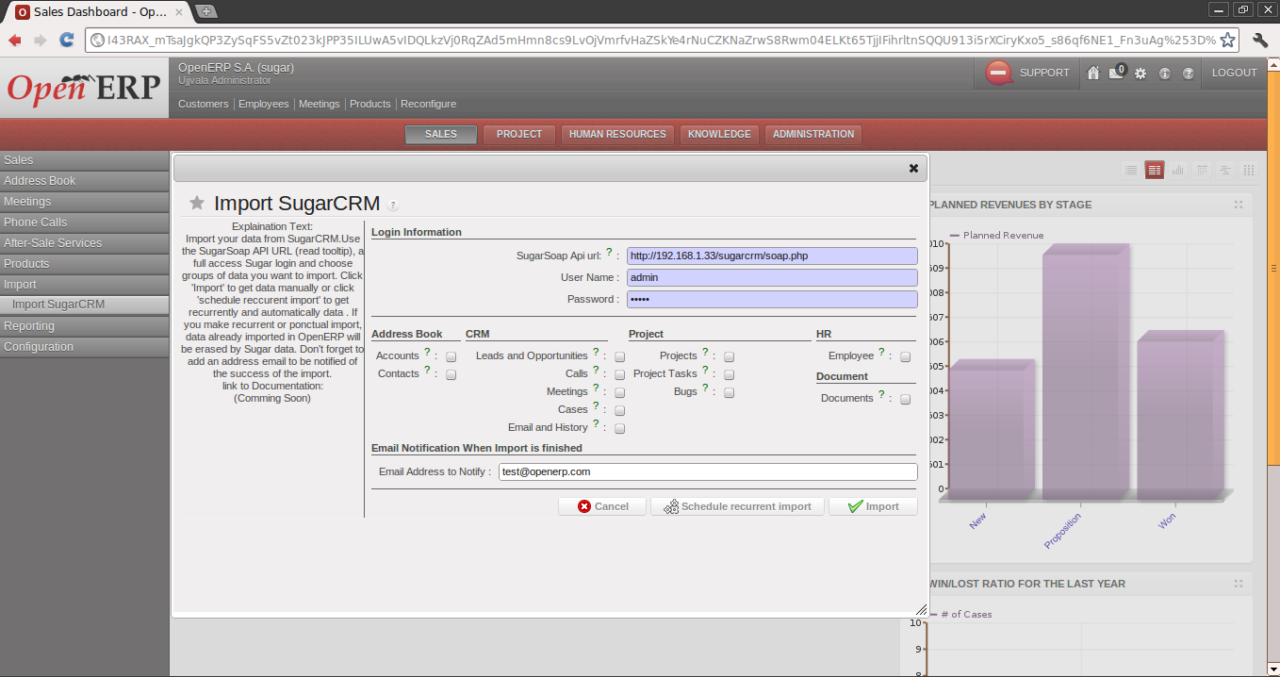

    - And Select List of Module to Import:
        - Address Book:
          - Accounts: Account are selected, Account Module Data of Sugarcrm Imported into Partners(Customers) form of OpenERP.
          - Contacts: Contact Data of Sugarcrm Imported into Partner Addresses of OpenERP.

2)CRM:
          - Leads And Opportunities: Leads are imported using type=”lead” into Leads form of OpenERP. Opportunities are imported using type=”opportunity” into Opportunity form of OpenERP.
2.Meetings: Meetings are selected, SugarCRM Meetings Tasks
data imported using type=”Tasks” into Meetings form of
Openerp.Meetings are imported into Meetings form of OpenERP.
3.Calls: Calls are selected, SugarCRM Calls data imported using “Inbound”
cateogry into Logged Calls form and using “Outbound” cateogry into
Scheduled Calls form of OpenERP

4.Cases: Cases are selected, SugarCRM Cases data imported in OpenERP
Claims Form of OpenERP.
5.Email And History: if Email and History is selected, SugarCRM Notes and
Emails data imported in OpenERP's Related module's History with attachment.

3) Project:
1.Project: Projects are selected, SugarCRM Projects data imported in
OpenERP Project Form.
2.Project Tasks: Project Tasks are selected, SugarCRM Project Tasks
data imported in OpenERP Project Tasks Form.
3.Bugs: Bugs are selected, SugarCRM Bugs data imported in
OpenERP Project Issue Form.
4)HR:
1.Employee: If Employees is checked, SugarCRM Employees data
imported in OpenERP Employees form.
5)Document:
1.Document:Documents are selected, SugarCRM Documents data
imported in OpenERP Document Form.

5) Email notification
Notification Email is send to specified
Email address of Email Notification field.
This Email contain information of start time and Finished time of Import.
Also contain How many record were Imported from which table and with some warning or not also.
6) Import
Import” button that will start process in backgroung
7) Schedule a recurrent
If User want to call Import Process through Scheduler ,by Clicking “Create Recurrent Import” you can create scheduler, which will run import process at specified interval.

8)MultiInstance Management Field :
MultiInstance name will be used to separate import from multiple SugarCRM login
instance.come from different server.MultiInstance used as Prefix of SugarCRM to
remove duplication of record come from different server.

